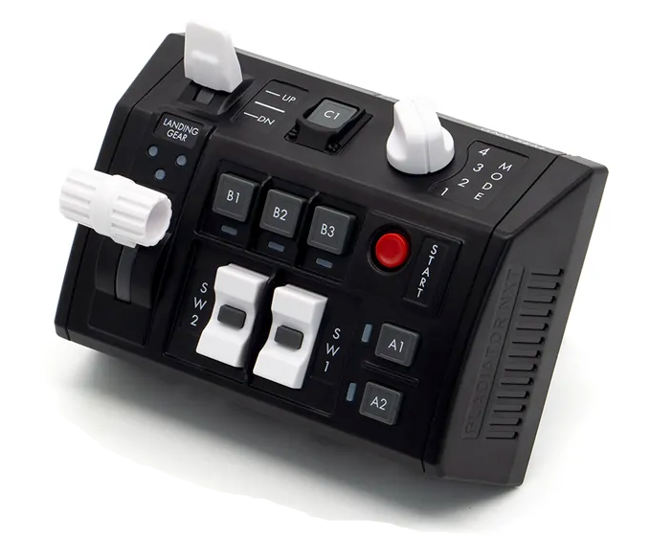
104 - Controls - GNX SEM-V
U=Up, D=Down, N=Neutral, F=Forward, B=Backward, L=Left, R=Right, P=Press, S-*=Shift-*, L-*=Long-*

Landing Gear lever
- U: --
- N: --
- D: --
Flaps Switch
- U: --
- N: --
- D: --
SW1 Rocker Switch
- U: --
- P: --
- D: --
SW2 Rocker Switch
- U: --
- P: --
- D: --
Start Button
- P: --
A1 Button
- P: --
A2 Button
- P: --
B1 Button
- P: --
B2 Button
- P: --
B3 Button
- P: --
C1 Button
- P: --
Mode Knob
- 1: --
- 2: --
- 3: --
- 4: --

